**Install Django and use with Pycharm**

**PART 1: Install necessary software**

1. Follow the setup instructions given in BB, if you do not have the necessary software installed.

2. Check Django version: $ **python -c "import django; print(django.get_version())"**

**PART 2: Run Django from Pycharm**

1. Start pycharm. Then **File 🡪 New Project**.

a) In left pane select “Django”

b) In dialog box enter path and project name (*mysiteS18*)

c) Click “More Settings” Enter APP name (*myapp*)

d) Click ***Create***.

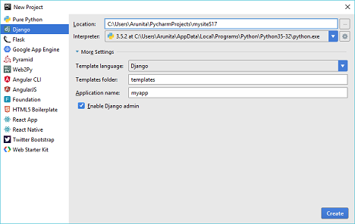

3. Click **Tools 🡪 Run manage.py Task …**

a) Create db. Type **migrate** in **manage.py** console. # Verify that db is created.

b) Create admin user. Type **createsuperuser** in **manage.py** console. Enter username, email, password as prompted.

c) Start server. Type **runserver 127.0.0.3:8080** in **manage.py** console.

d) Go to 127.0.0.3:8080 and see what it shows.

**Work with HTML/CSS**

1. Create a website for a **sport products store**. The website consists of the main ‘*Home’* page as well as links to the following pages (which you will also create): *About*, *My Account*, *Purchase Online*. You must also create a CSS style sheet that will be used by your html pages as well as additional web pages as needed. Your website should have the following features:

**PART 3: Create content**

1. An initial version of the home page *index0*.*html* is given. Update this file so that each item in the list of links appears on the same line.
2. Add a hyperlink to the paragraph “Clothing” which takes you to *clothing.html*. The *clothing.html* page shows a list of the cloths items available in the store. You can arrange the items into 2 categories: Men Clothing and Women Clothing. The ‘*Clothing’* page should contain *ordered list* (using roman numerals) of cloths items. Each item should have a clickable image associated with it. Clicking on the image should bring to a page with the product’s details like the price, sizes, colors, … etc.
3. The ‘*clothing*.*html’* should contain at least 12 images. The images should be *100px wide*, *120px high* with a *margin of 10px*. Each image should ‘*float:right*’.
4. Similarly, update “*Equipment*” link in the home page to take you to *sportequip.html*. This page should give a list of sport equipment available in the store, e.g., treadmills, elliptical machines, exercise bikes, …, etc.
5. The “Other Items” link will take you to “*others.html*” which should give a list of other items available at the store, e.g. footballs, hand grips, jump robes, lifting accessories, mats, ...etc. You can add other items as appropriate.
6. The *about.html* page should give a few short paragraphs describing the store, e.g. locations, shopping hours, services, promotions, and other useful information.
7. The *myacct.html* page should display a short message “This is my account!”, you can add more information if appropriate.
8. The “*Purchase Online*” link should take you to the page *purchase.html* which displays a **form**, where the user can enter the following information: *Full* *Name, Email, Method of Payment* (Debit or Credit using radio button input), *Item to Purchase*, and *Address*. The first four fields are required and the 5th is optional. There should be some checkbox on the page explaining if the user is willing to receive email updates about upcoming new promotion and arrival products. After the form is submitted, they should see a message saying, “**Your Order was successfully submitted!**”.
9. Each page created above should have a common main heading (<**h1**>) “Welcome to the LifeSport Store!!” and an appropriate subheading (<**h2**>). Each page should also include the horizontal list of navigation links created in **step 1a**.

**PART 4: Edit styles**

1. Use a common *background image* and for each page. The background image and styles for **h1**, **h2** should be defined in your *css stylesheet*.
2. Create a logo for your store that should be displayed in the upper-left corner of each page. Use a <**div**> element to style the logo in the css style sheet.
3. The *about.html* page should have at least 1 para with an ‘**id’** attribute. Use **id** attribute to define formatting styles for the paragraphs in the <**head**> section of the html page.
4. Use a <**div**> element to style the navigation bar created in **step 1a**. Use ‘css style sheet’ to select the *background color* for the <**div**> element.